Jazz Goes to Town introduces musicians and starts ticket sales!

The international music festival Jazz Goes to Town will take place this year for the 25th time, during the second week of October (8.–12. 10. 2019). The festival will have stages in various locations around Hradec Králové including the town‘s very streets. Visitors will have a chance to see bands, groups, and formations of artists from twenty countries and four continents. More than half of them will perform in the Czech Republic for the first time. Tickets are now on sale!

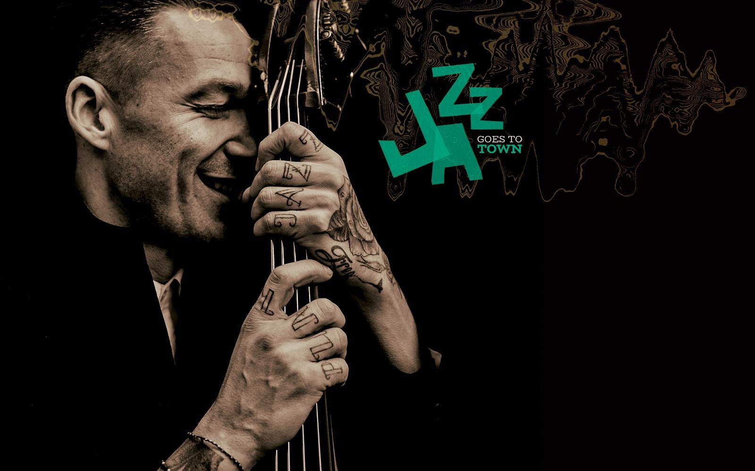

PRESS RELEASE: 1. 8. 2019

This year’s Hradec Králové festival will feature several Czech premieres of international instrumentalists. One of them is the energetic trio Digital Primitives, led by Cooper-Moore, one of the most prominent personalities of New York’s independent jazz scene. The same evening will be completed by an international septet Ziv Taubenfeld's FULL SUN, featuring musicians from seven countries. This year a thunderstorm of energetic music of Dutch The Zebra Street Band will also hit Czech Republic for the first time. They will lead visitors through the streets of historic Hradec Králové and, as is tradition, finish the festival with an evening club afterparty. The 25th Jazz Goes to Town festival promises an intoxicating ending, in the form of the fifteen-member Nordic big band Paal Nilssen-Love’s Large Unit’s performance.

The festival will start off with an international octet Didrik Ingvaldsen Ensemble that crosses borders of both geography and style and creates a mix of Scandinavian, Berlin and Czech jazz scene. Their leader, trumpetist and composer Didrik Ingvaldsen, is active on the jazz scenes of Norway, Berlin, and New York. Festival visitors will get a taste of London jazz from the quartet Blinkers Golding’s Band, led by saxophonist Binker Golding, receiver of a number of awards (MOBO Best Jazz 2015, Jazz FM Award, Parliamentary Jazz Award), performing in Czech Republic for the first time.

The festival will of course not forget bands from the Czech Republic and its closest neighbours. One of them is a Polish quintet of basist Wojtek Mazolewski who has been a star of Polish modern jazz for the past decade. The small Hradec PETROF Gallery will belong to one of today’s most prominent Czech musicians Beata Hlavenková, who created music for the television film Dukla 61. Other Czech representants at the festival are the iconic Prague band MUFF with a twenty-year-old tradition and a group of young jazzmen Pavel Zlámal & PQ. This band started at Janáček Academy of Music and Performing Arts in Brno, under the direction of experienced saxophonist Pavel Zlámal. He first performed at the festival at 2017 as a solo artist.

As is tradition, the festival will feature a smaller experimental performance, this time by an American-Austrian duo of Ken Vandermark and Christof Kuzmann. A musical project of American virtuoso saxophonist Michael Moore and Israeli bass clarinetist Ziv Taubenfeld, created especially for this year's Jazz Goes to Town, will perform in the heritage site of ​​the Chaplain Ambrož Choir. The Czech-German duo Klaus Kugel & Pavel Hrubý will play at the Hradec City Music Hall. Pavel Hrubý, a talented wind instrument player, has been in the heart of Czech modern jazz for over fifteen years. Prominent European jazz drummer Klaus Kugel will add to the duo‘s music, next to the classical drum set, original percussion instruments and self-made objects.

FESTIVAL TICKETS

Tickets can be purchased from 1st of August 2019 at www.goout.cz or at GoOut ticket offices (Prague, Brno, Ostrava, Pilsen) or from 5th of August 2019 at two Hradec Králové locations – Bio Central ticket office and Café na kole (during opening times, only cash payments accepted). Ticket prices range from 100 to 400 Kč and are lower during advance booking than directly at the concerts. Advance booking finishes one hour before the start of each performance.

Discounted prices are available to students, older citizens, and EYCA card holders. The festival offers two types of passes – full festival pass for 1 500 Kč, or Friday and Saturday pass for 800 Kč.

See the complete programme and more information at the festival website www.jgtt.cz.

You can follow us on FACEBOOK and INSTAGRAM.

Press contact persons:

Karolína Pláničková
karolina.planickova@jgtt.cz
+420 723 518 595

Daniel Brátka
daniel.bratka@jgtt.cz
+420 731 411 025

Festival photos download:
bit.ly/JGTT2019_pressfoto

PARTNERS OF THE 25th JAZZ GOES TO TOWN FESTIVAL:

General partners
Hradec Králové a Calendarium Regina

Partners
Královéhradecký kraj, Ministerstvo kultury, Státní fond kultury, Petrof, Květiny La Vital, Vinařství Kněží hora

Cooperation
EYCA, Nová síť, Stagelab

Festival stages
Bio Central, Klicperovo divadlo, Galerie moderního umění, NãPLAVKA café & music bar, Městská hudební síň, PETROF Gallery, Sbor kněze Ambrože

